**NAAN MUDHALVAN**

SALESFORCE ASSIGNMENT

COLLEGE :**PSN INSTITUTE OF TECHNOLOGY AND SCIENCE**

NAME : MALLIKA DEVI M

REG NO : 952420104015

NM ID : F2077AFC7BDACDC82A243314A17BEBA5

**Task – 1 :**

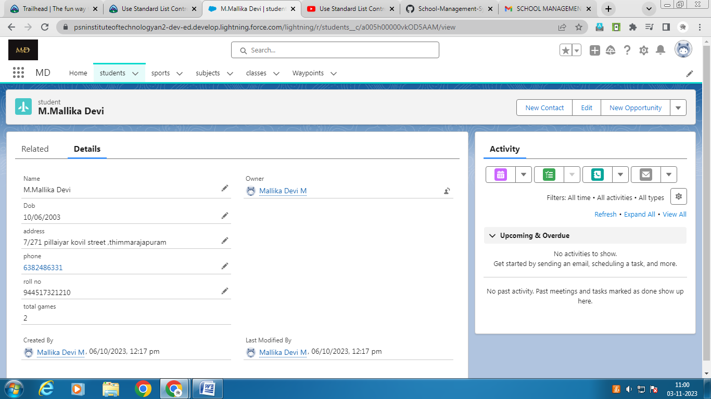

**Task – 2 :**

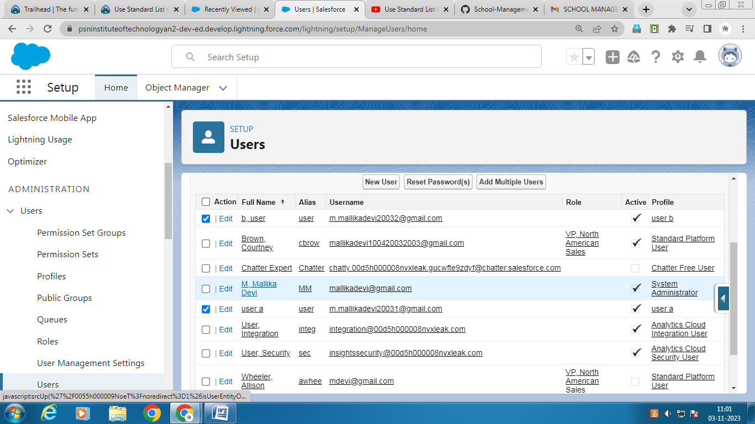

**Task – 3 :**

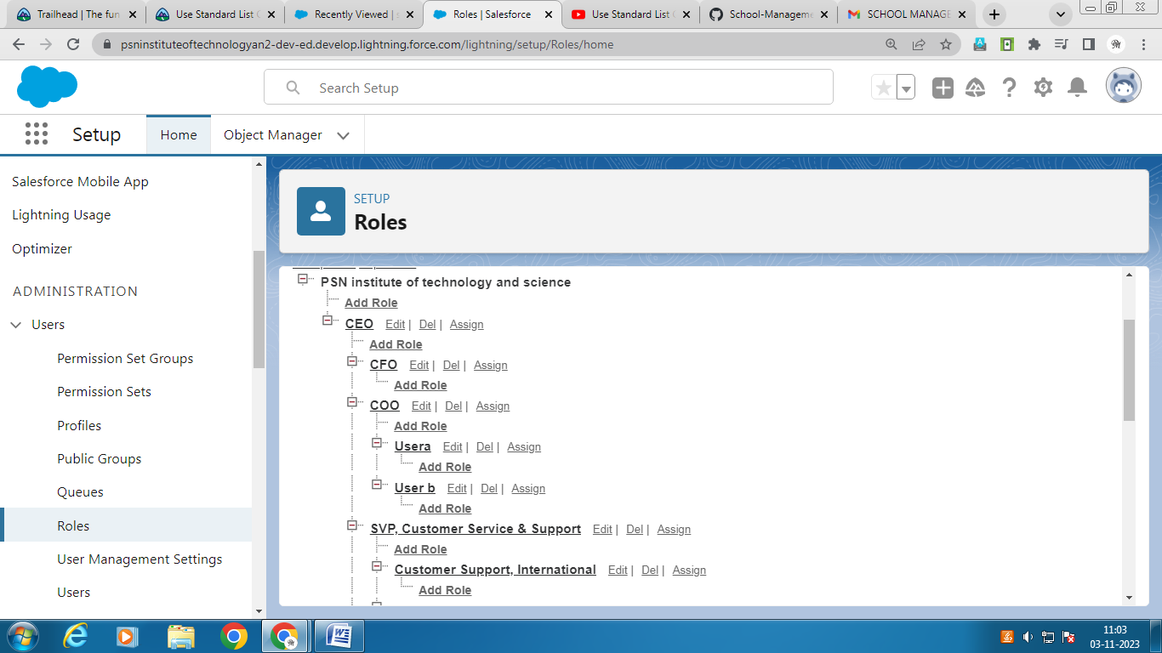

**Task – 4 :**

